**CSP Final Review**

## **Objective 1**: Identify the roles of variables.

1. Describe the purpose of each of the variable roles below: (1.1.5, 1.1.6)
   1. Fixed
   2. Most recent
   3. Accumulator
   4. Aggregator
   5. Stepper
   6. Walker
   7. Best so far
   8. One way flag

## **Objective 2:** Explain the roles of driver and navigator.

1. When coding with a partner, explain the tasks that the driver and navigator would complete. (1.1.3)

## **Objective 3:** Create and analyze algorithms to determine their effect.

1. 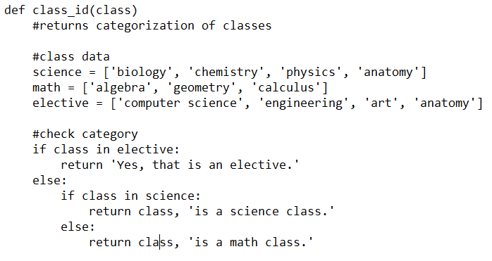Use the class_id function to the right to answer the following questions. (1.3.4)
2. What return value would be created if anatomy was used as an input?
3. What return value would be created if biology was used as an input?
4. What return value would be created if history was used as an input?
5. What is a flaw in this function?

## **Objective 4:** Implement debugging techniques.

1. Identify what is causing an error in the functions below. (1.3.2)
   1. The function below should solve for a hypotenuse of a right triangle.

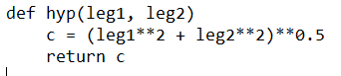

* 1. The function below should solve for the area of a circle.

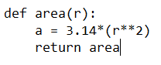

* 1. The function below should solve for the mean of 5 numbers.

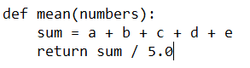

## **Objective 5:** Create programs that are efficient and use programming constructs (if-else statements, loops, conditionals, etc.) correctly.

1. Create a new function written in Python that has no parameters called ageCheck() that meets the criteria listed below. (1.3)
   1. Use the raw_input command to ask for the user’s age  
      Be sure you change this input to an integer value
   2. If the user’s age is less than 13 return a string that states they are too young.  
      For example, if a user enters 7 when prompted for their age, the function will return ‘You are only 7. You must be at least 13 to create an account!’
   3. If the user’s age is greater than or equal to 13, but less than 18 return a string that states they can create an account, but they must ask for their parent’s permission.  
      For example, if a user enters 15 when prompted for their age, the function will return ‘Since you are 15 you can create an account, but please ask for your parent’s permission!’
   4. If the user’s age is 18 or larger return a string that states they can create an account.  
      For example, if a user enter 37 when prompted for their age, the function will return ‘Since you are 37 you can create an account.’

def ageCheck():

## **Objective 6:** Read code written by others and explain individual segments of the code.

1. Use the code below to answer the following questions: (1.4.2)
2. What is the meaning of ax[]?
3. Is subplots a method or an object?
4. What data type of object is ax?
5. Using correct terminology, describe this line of code  
   ax[1].imshow(img, interpolation='none')

|  |  |
| --- | --- |
| 08  09  10  11  12  13  14  15  16  17  18  19  20  21  22  23  24  25  26 | '''Read the image data'''  *# Get the directory of this python script*  directory = os.path.dirname(os.path.abspath(__file__))  *# Build an absolute filename from directory + filename*  filename = os.path.join(directory, 'woman.jpg')  *# Read the image data into an array*  img = plt.imread(filename)  *# Create figure with 2 subplots*  fig, ax = plt.subplots(1, 2)  *# Show the image data in the first subplot*  ax[0].imshow(img)  ax[1].imshow(img, interpolation='none')  ax[0].set_xlim(135, 165)  ax[0].set_ylim(470, 420)  ax[1].set_xlim(135, 165)  ax[1].set_ylim(470, 420)  *# Show the figure on the screen*  fig.show() |

1. Answer the questions about the block of code below. Assume img has been instantiated as an ndarray object. (1.4.3)
   1. Describe the result of line 26.
   2. Describe the result of line 27.
   3. Describe the purpose of the for loop (lines 28-30).

|  |  |
| --- | --- |
| 22  23  24  25  26  27  28  29  30 | *###*  *# Does stuff.*  *###*  x = len(img)  y = len(img[0])  for row in range(200, 220):  for column in range(50, 100):  img[row][column] = [0, 255, 0] |

1. Completely describe each of the highlighted lines of code. (1.4.5)

|  |  |
| --- | --- |
| 6  7  8  9  10  11  12  13  14  15  16  17  18  19  20  21  22  23  24  25  26  27  28  29  30  31  32  33  34  35  36  37  38  39  40  41  42  43  44  45  46  47  48  49  50  51  52  53 | **def** round_corners(original_image, percent_of_side):  """ Rounds the corner of a PIL.Image  original_image must be a PIL.Image  Returns a new PIL.Image with rounded corners, where  0 < percent_of_side < 1 is the corner radius as  portion of shorter dimension of original_image  """  *#set the radius of the rounded corners*  width, height = original_image.size  radius = int(percent_of_side * min(width, height)) *#highlight #1*  *###*  *#create a mask*  *###*  *#start with transparent mask*  rounded_mask = PIL.Image.new('RGBA', (width, height), (127,0,127,0))  drawing_layer = PIL.ImageDraw.Draw(rounded_mask)  *# Overwrite the RGBA values with A=255.*  *# The 127 for RGB values was used merely for visualizing the mask*  *# Draw some stuff to fill interior with opaqueness*  drawing_layer.polygon([(radius,0),(width-radius,0),  (width-radius,height),(radius,height)],  fill=(127,0,127,255)) *#highlight #2*  drawing_layer.polygon([(0,radius),(width,radius),  (width,height-radius),(0,height-radius)],  fill=(127,0,127,255))  *#Draw four filled circles of opaqueness*  drawing_layer.ellipse((0,0, 2*radius, 2*radius),  fill=(0,127,127,255)) *#top left*  drawing_layer.ellipse((width-2*radius, 0, width,2*radius),  fill=(0,127,127,255)) *#top right*  drawing_layer.ellipse((0, height-2*radius, 2*radius,height),  fill=(0,127,127,255)) *#bottom left*  drawing_layer.ellipse((width-2*radius, height-2*radius, width, height),  fill=(0,127,127,255)) *#bottom right*  *# Uncomment the following line to show the mask*  *# plt.imshow(rounded_mask)*  *# Make the new image, starting with all transparent*  result = PIL.Image.new('RGBA', original_image.size, (255,0,0,1)) *highlight #3*  result.paste(original_image, (0,0), mask=rounded_mask)  **return** result |

1. Describe each line of highlighted code below. (2.2.1)

<script type="text/javascript">

var currentTime = new Date();

var hours = currentTime.getHours();

var minutes = currentTime.getMinutes();

var suffix = "AM";

if (minutes < 10)

minutes = "0" + minutes; HIGHLIGHT #1

if (hours >= 12) {

suffix = "PM";

hours = hours - 12;

}

if (hours == 0) {

hours = 12;

}

document.write("<b><div id='d1'>" + hours + ":" +

minutes + " " + suffix + "</div></b>"); HIGHLIGHT #2

</script>

**Objective 7**: Define abstraction and identify what is above or below a given rung on the ladder of abstraction.

1. Give an example of a programming language with a high level of abstraction and an example of a programming language with a low level of abstraction. (1.2.1, 1.3.1)
2. What is machine code? (1.3.1)
3. What is the difference between procedural abstraction and data abstraction? (1.4.1)

## **C:\Users\jewan\Downloads\112e.jpgObjective 9:** Create a program from a state diagram or flowchart and describe a program’s flow using a state diagram or flowchart.

1. Use the state diagram of the LightBot character to the right to answer the following questions. (1.1.2)
   1. What is LightBot’s current location?
   2. What other locations could Lightbot move to with one action?

## **Objective 10:** Explain the purpose for version control and use a method to track revision and versions while working on a coding project.

1. What is the purpose of a version control system? (1.3.9)

## **Objective 11:** Describe the abstraction and perform the appropriate calculations between binary, RGBA, and ASCII.

1. How many bits are in a byte?
2. Convert the following binary values to their base 10 values: (1.2.1)
   1. 01100110
   2. 10000101
   3. 00001111
3. Convert the following base 10 values to their binary values: (1.2.1)
   1. 15
   2. 39
   3. 202
4. Estimate RGB values for each of the following colors: (1.2.1)
   1. Red
   2. Green
   3. Blue
   4. White
   5. Black
   6. Magenta
   7. Cyan
5. How many bytes does each pixel in an image contain if the pixel contains an alpha channel? (1.4.4)

## **Objective 12:** Define lossy and lossless and identify when a given file conversion is lossy or lossless.

1. What are the pros and cons of compressing data? Address transmission speed, fidelity, and lossiness in your answer. (1.2.1)
2. What occurs to the analog data on a record when you convert it to digital data so you can listen to the music from your phone? (1.2.1)

## **Objective 13:** Use basic constructs in code development (if-else, while loop, etc)

1. Evaluate the following Python algorithms: (1.3.2, 1.3.3)
   1. 7%2
   2. 7/2
   3. 7.0/2
   4. 8**2 == 16
   5. (5-2)**2 >= 8
   6. 9+1 != 10
2. Explain the difference between a for loop and a while loop. (1.3.7., 1.3.8)

## **Objective 14:** Distinguish among data types in a program.

1. Identify the type of data in Python for each example below: (1.3.2)
   1. 3.14
   2. (2, 4, 6, 8, 10)
   3. ‘alphabet’
   4. 5230
   5. 3**2 == 9
   6. [A, B, C, D, F]
2. Evaluate the following inputs: (1.3.5, 1.3.6)
3. 4 + 6
4. ‘4’ + ‘6’
5. ‘4’ + 6
6. int(‘4’) + 6
7. str(4) + ‘6’
8. Describe the differences and similarities among a tuple, list, array. (1.4.4)

## **Objective 15:** Use and create functions and external libraries as needed to create program functionality.

1. What is the purpose of using a python library? What is an example of a library that we have used this year? (1.3.2)

## **Objective 16:** Call a class to instantiate an object and use the object’s methods and attributes in a program.

1. In object-oriented programming, (1.4.2)
2. what is an object?
3. what is a method?
4. what is a property?
5. Using the UML class diagram below and the partial class definition, answer each question. (1.4.1)
6. What is the default color of a NoteCard object?
7. What is the result of this line of code?

thisCard = NoteCard()  
**print** thisCard.color

1. How could you complete this line of code to create a blue notecard?

thatCard =

1. What is the result of this line of code?

thatCard.draw_circle()

|  |
| --- |
| NoteCard |
| height  width  color |
| draw_circle() |

**class** **NoteCard**(object):

**def** __init__(self, height=76.2, width=127,color='#FFFFFF'):

""" Creates a new 3 in X 5 in notecard.

Height and width expressed in millimeters

color is expressed in a 6-digit hexadecimal

"""

*# Implement with a human so that:*

self.height = height

self.width = width

self.color = color

**def** draw_circle(self, diameter=20, color='#00FF00', fill=True):

""" Draws a circle on a random location on the ball

uses colored pencil

diameter is expressed in millimeters

color is expressed in a 6-digit hexadecimal string

"""

*# Implement with human*

## **Objective 17:** Deconstruct a URL and identify the path of data exchanged between a web browser and a website.

1. Match each portion of the website address with the term that best describes it. (2.1.2)

https://davisrules.com:443/compsci/csp/index.html?message=6&student=3

|  |  |
| --- | --- |
| https  davisrules.com  443  compsci/csp/  index.html  message  6  student  3 | 1. Port 2. path 3. parameter #1 key 4. parameter #1 value 5. parameter #2 key 6. parameter #2 value 7. resource name 8. host name 9. scheme or protocol |

1. Describe each step in the diagram below. Include in your description a discussion about how and why the servers are communicating at each step. (2.1.3)

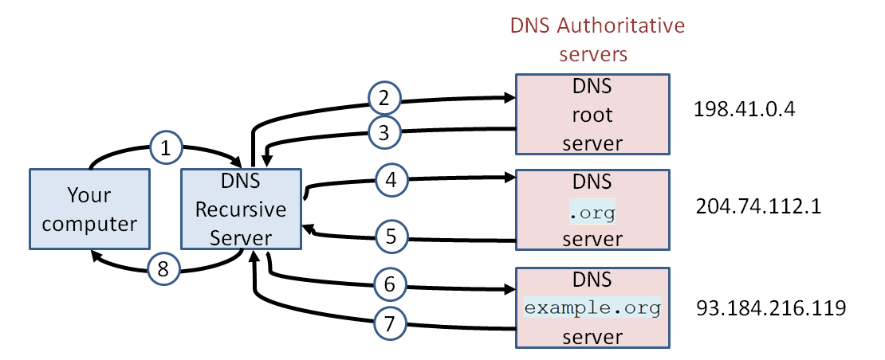

## **Objective 18:** Describe the process of computer exchanging secure information.

1. Give an example of a secure website’s URL and an unsecured website’s URL. (1.2.2)
2. Identify the purpose of each protocol. (2.1.4)
3. IP
4. TCP
5. DNS
6. HTTP
7. What is an SSL certificate? (2.1.5)

## **Objective 19:** Describe the purpose of particular data structures and pieces of code contributing to the delivery and rendering of a web page.

1. What is the difference between IPv4 and IPv6? (2.1.1)
2. What is the basic function of the cookie and where is it stored? (2.1.2)
3. There are 5 blocks in the CSS file below. Describe the purpose of each of these blocks. (2.1.4)
4. body
5. h1
6. table
7. tr
8. th

|  |  |
| --- | --- |
| 1  2  3  4  5  6  7  8  9  10  11  12  13  14  15  16  17  18  19  20  21  22  23  24  25  26  27  28  29 | body{  font-family: "Marker Felt", "Comic Sans MS", fantasy;  color: #003366;  }  h1 {  font-size: 1.3em;  text-align: center;  }  table {  margin-left: auto;  margin-right: auto;  text-align: left;  border-collapse: collapse;  cellspacing: 0px;  }  tr {  border: 1px solid #ffffff;  text-align: center;  background-color:#9FB6CD;  }  th {  text-align: center;  color: #ffffff;  background-color: #003366;  } |

1. What role do each of the following languages play in creating a website? (2.2.1, 2.2.2)
2. HTML
3. CSS
4. JavaScript
5. PHP
6. mySQL

## **Objective 20:** Describe potential vulnerabilities in network security and identify steps that can be taken to reduce risks.

1. Define encrypt and decrypt. (2.1.5)
2. Identify the difference between public key encryption and private key (symmetric) encryption. (2.1.5)

## **Objective 21:** Distinguish between events and event handlers.

1. In a block of code, what is the purpose of an event and a handler? (1.1.4)
2. Identify the events and handler in the blocks of code below. (1.1.4)

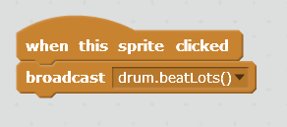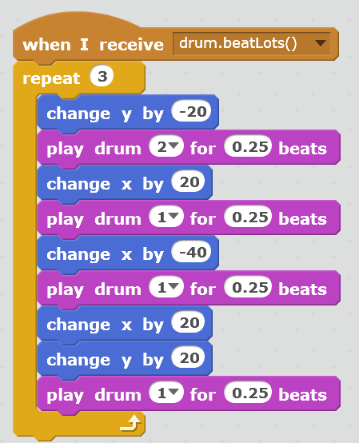

# **Other Objectives**

* Objective 22 - Justify the need for ethical behavior and predict the outcomes for ethical and unethical behaviors in different career paths.
* Objective 23 - Evaluate a user interface based on the principles of HCI.
* Objective 24 - Identify and evaluate risks while using the Internet and take appropriate action to limit risk.
* Objective 25 - Evaluate the benefits and risks of the public availability of information versus the right to personal privacy.
* Objective 26 - Identify and interpret patterns in big data to make a conclusion on a given topic.
* Objective 27 - Extract meaning from data visualizations. Critique data visualizations for correctness and clarity.
* Objective 28 - Justify a prediction using conclusions drawn from simulations.